KievProp INSTALLATION INSTRUCTIONS 410-221-8017
www.kievpropamerica.com

Install Instructions for engines with ROTAX (582, 503) 2 cycle type

Prop Flange and 75mm Bolt Pattern

- Disassemble prop hub, noting orientation of prop hub halves.
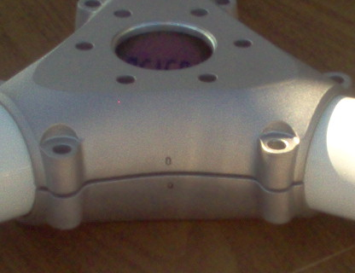
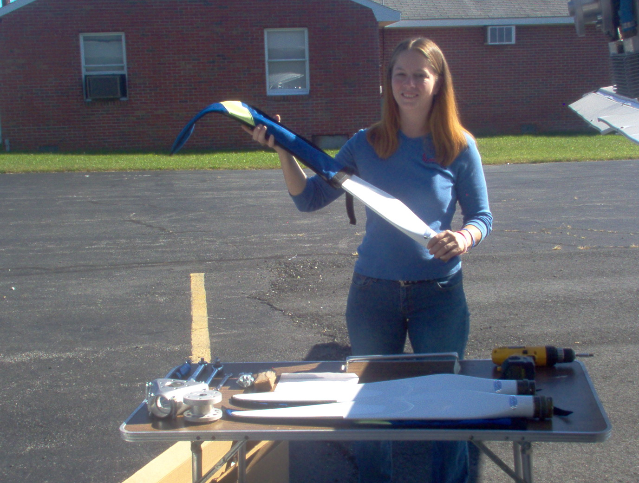
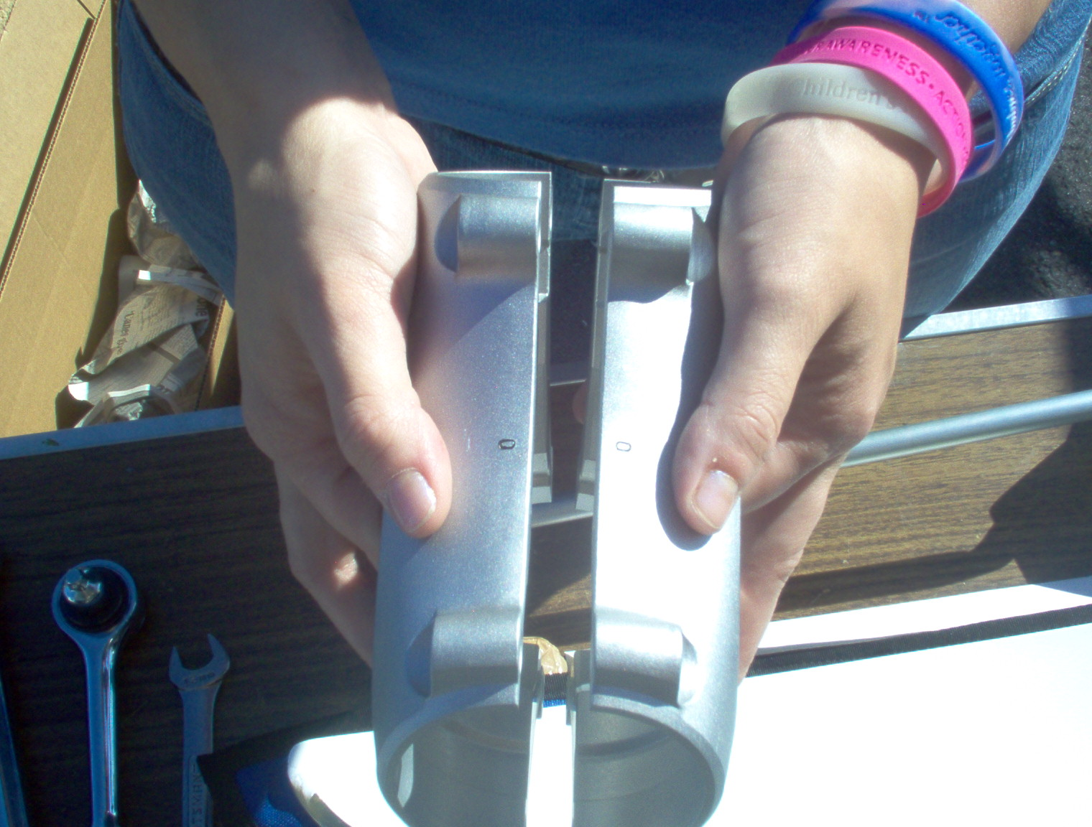

The stamped number on each Hub half must remain adjacent to each other during re-assembly!

- Inspect each blade and remove any tape or glue residue from brass leading edges. Install propeller blades into their positions between the hub halves. Use caution to not drop or hit blade tips on the ground or hard surface. The tips are the most fragile area of the prop! NOTE: There is no longer a tiny hole in the tip of the blades to expel moisture. The blades now have an Epoxy Foam core.

- Install shoulder bolts with the washers and Nyloc nuts and tighten slightly to hold blades in place.
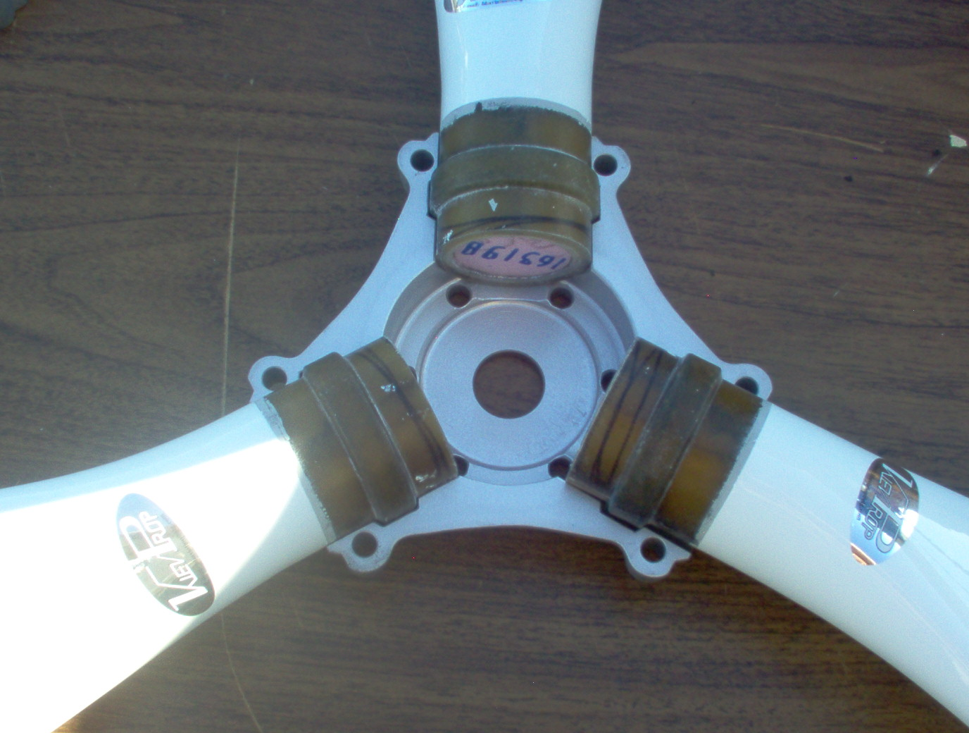
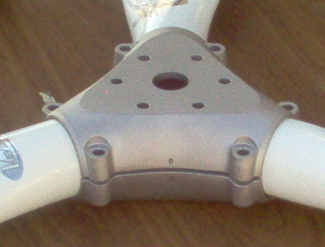

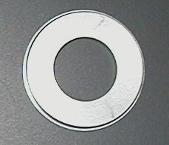
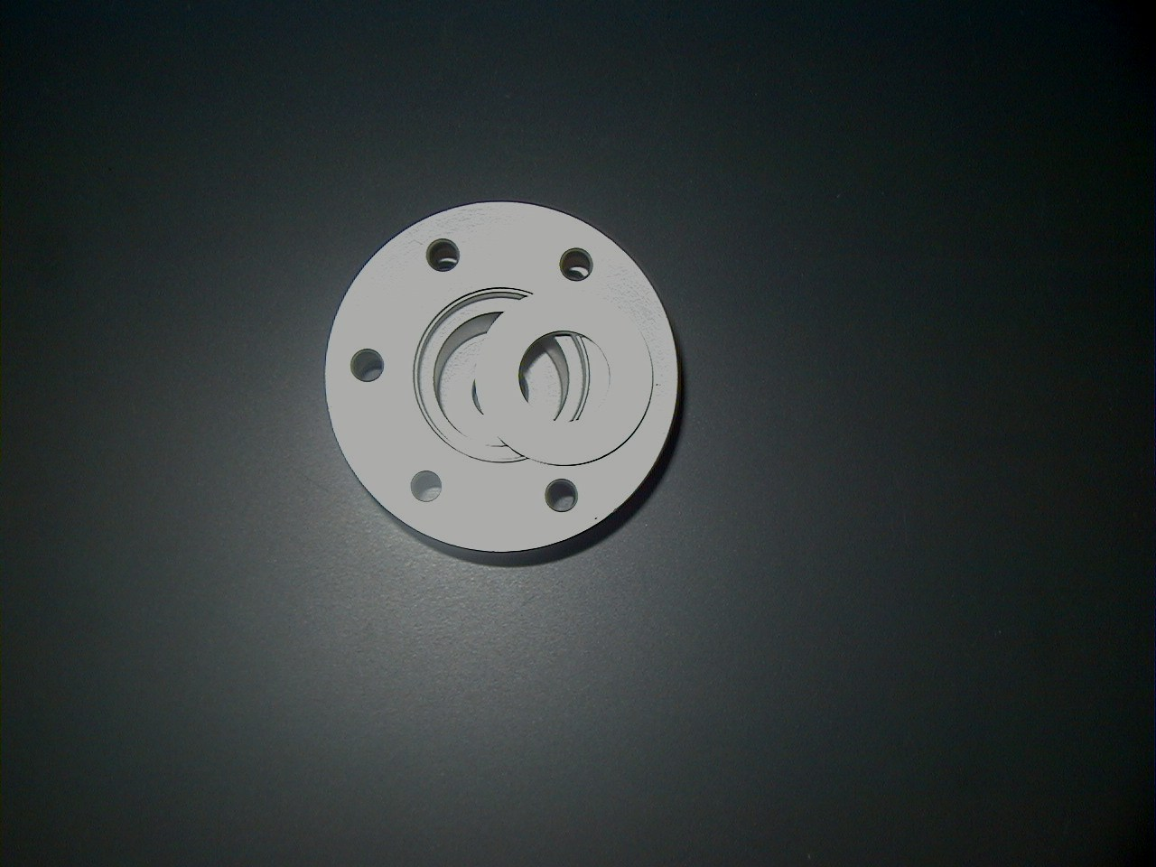
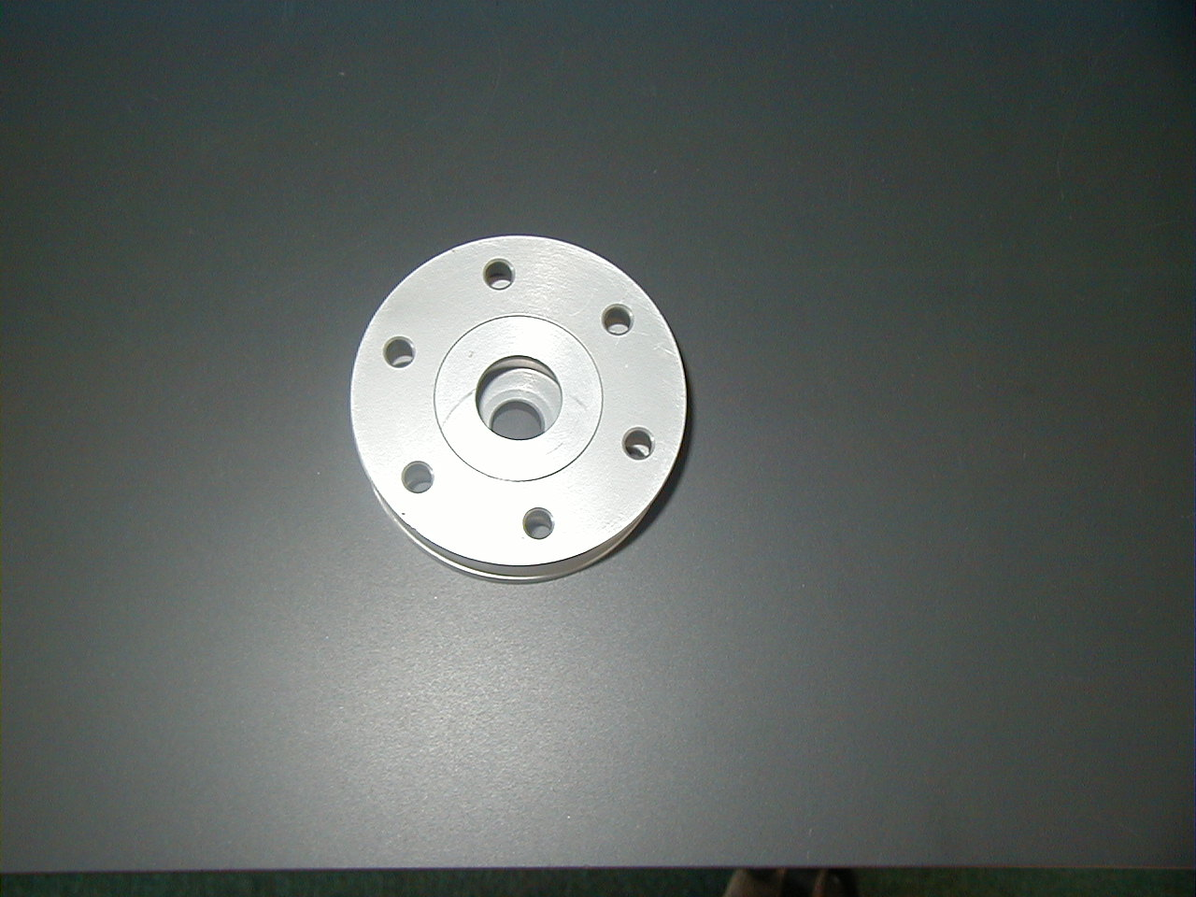

IMPORTANT NOTE! There may be a small-machined insert that fits into the hub and / or spacer. If using a Spinner, install the insert into the hub and not behind the Spinner backing plate (see below, left). The backing plate should be flush against the flange or Spacer.
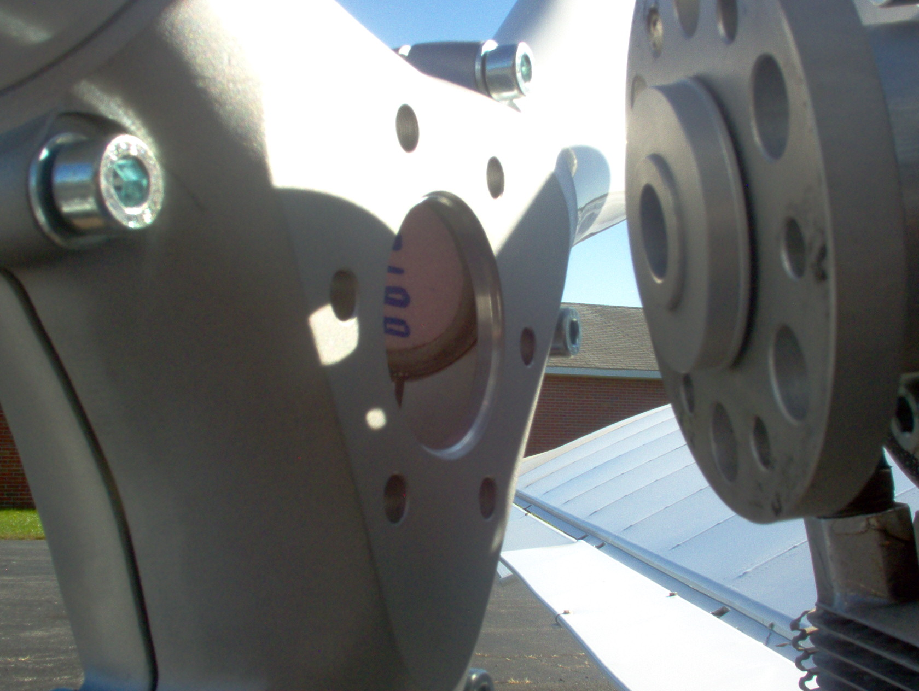
On most 2-cycle applications, this insert must be installed in the hub. If you have a spacer, it too will have an insert and must be installed as well. If your propeller hub has a small centering hole on each half of equal diameter (approximately 1”), then it does not require the insert. Most 4-cycle applications have no need for the insert because they have a larger centering hole on one side. IMPORTANT: If you have a hub with the large centering hole on one side and a smaller one on the other do not attempt to mount the hub backwards, with the large hole to the outside. Call for the insert! On aircraft of “Pusher” configuration, with propeller assembly flush against the prop flange, make sure that there is at least 3.75” clearance between anything forward of the prop tips. If clearance is less, you will require a spacer on the gearbox prop flange before mounting the propeller. WHEN EVER IN DOUBT, CALL US!!!
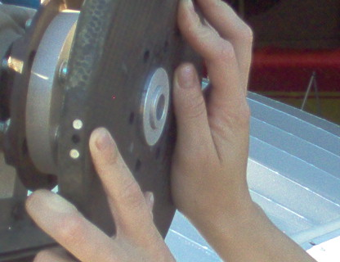

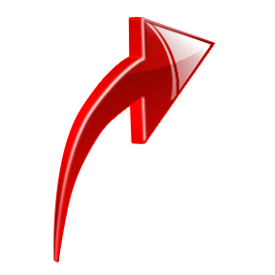

WRONG!

NOTE: On all applications, if you are using a Spinner, install the backing plate between the spacer and the prop hub. Install Spinner dome after you have run the engine, rechecked the torque as instructed below and are satisfied that everything is correct. Otherwise, removal of the Spinner dome will be necessary.
SECURING ASSEMBLED PROP TO ENGINE:
5. Secure (finger tight) the propeller to the engine with the supplied 8.8 X 1.25mm bolts, washers and nuts.
NOTE: The supplied bolts are grade 8.8 metric and the nuts are metric Nyloc.

6. With all bolts slightly tightened, you should be able to easily adjust the pitch on the blades. Make sure at this time that the leading edge of all blades are facing in the correct direction and are not backwards.
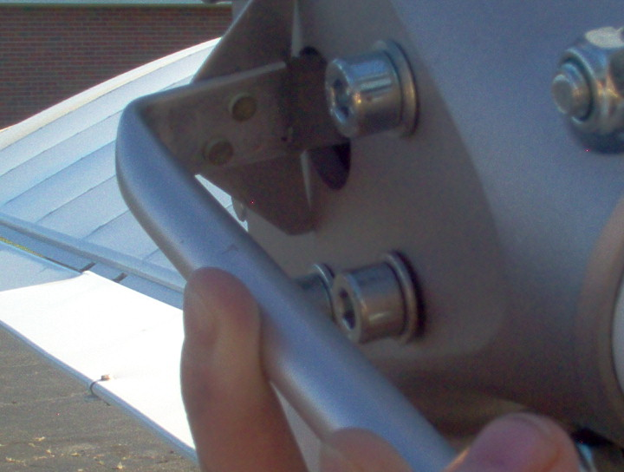
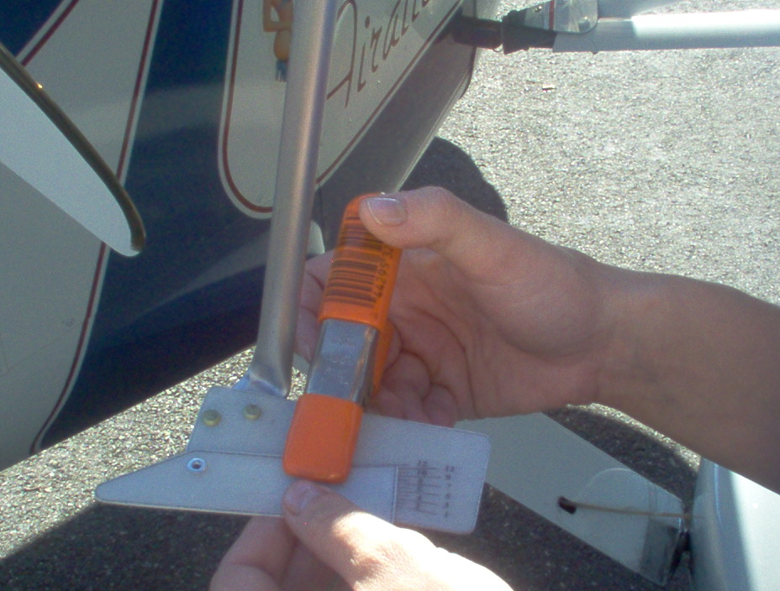
7. Set the reference scale on the protractor
to the recommended arbitrary setting
and clamp in place.
Typical ROTAX starting points:
503, between 2 and 4
582, between 11 and 14,
Due to variations in gearboxes, etc. more
adjustments are usually required to dial in
the “perfect” pitch setting.

- Fit the aluminum end of the protractor
into the center hole of the prop hub so that
the aluminum ears are both touching the flat face of the hub. Be careful to keep the “ears” against the hub for accurate adjustments.
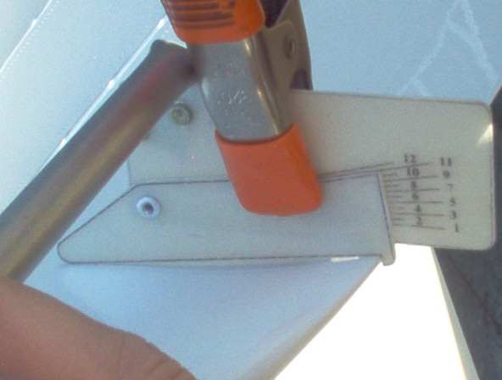
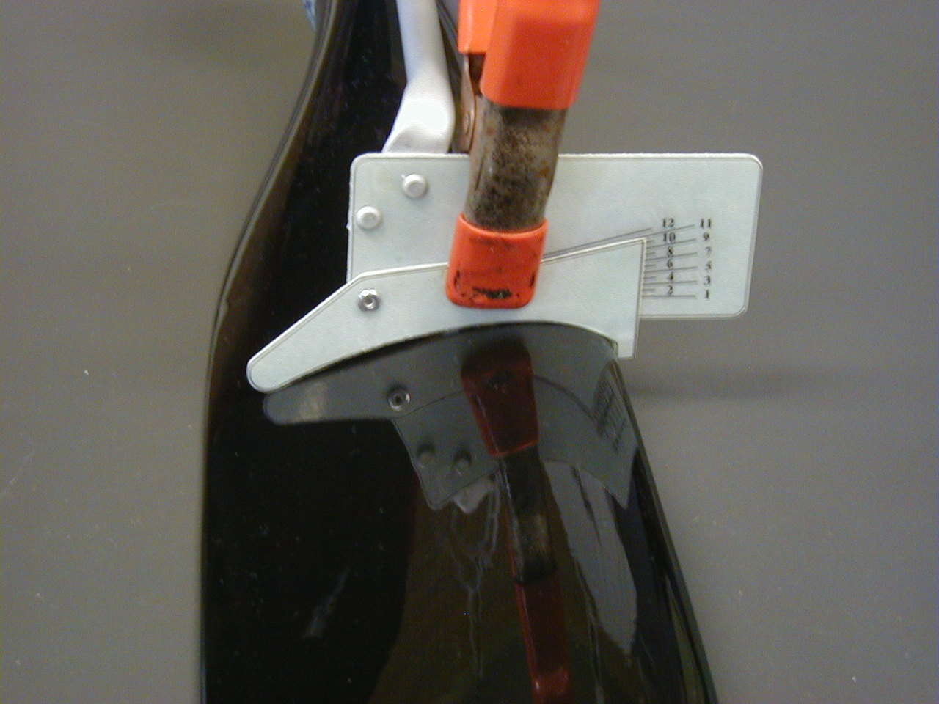

PUSHER TRACTOR
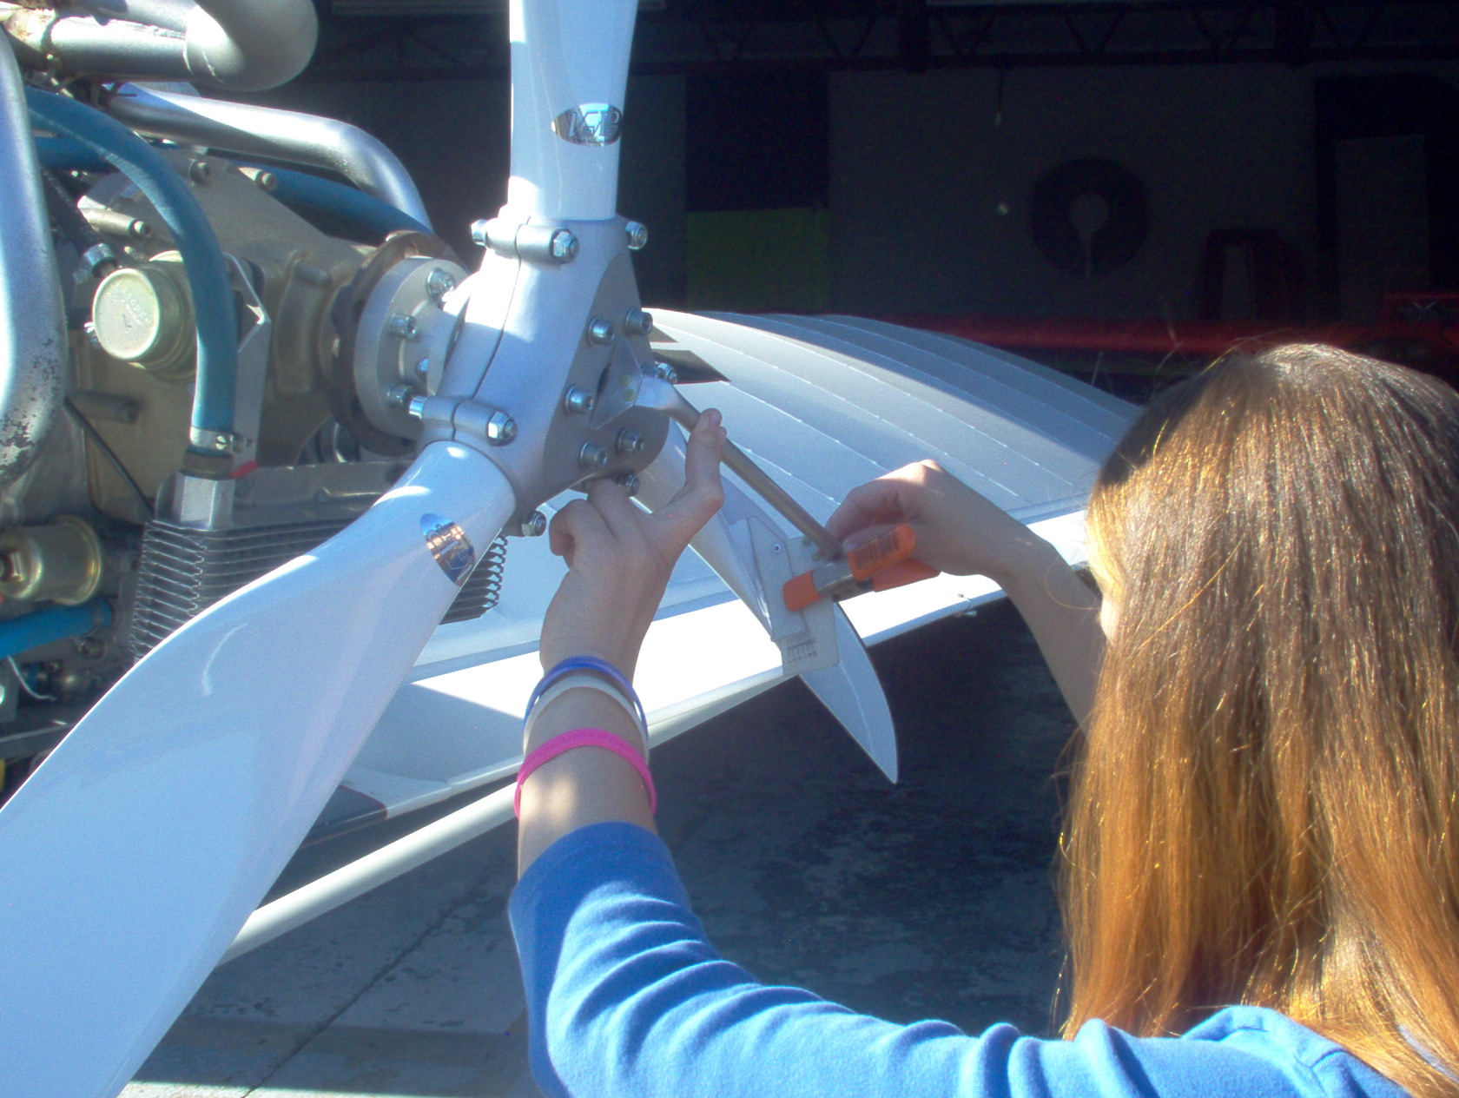
- For Pusher aircraft, place the notched end of the protractor against the trailing edge of each prop blade. For Tractor applications, the notched end should be on the Leading edge of each blade. Rotate the blade until it sits flat against the leading and trailing edge of the protractor.

IMPORTANT: Ensure that the ears on the protractor are flush against the hub when the setting the blade angle. Carefully torque the two nuts on the shoulder bolts to 3-4 foot lbs. to hold the blade setting. Repeat procedure for the other blades.

10. Using a calibrated torque wrench, after all blade angles have been set, tighten ALL the Nyloc nuts sequentially with 5 ft. lb. increments to 18.44-foot lb. This will help to insure proper tracking. Check the pitch of all blades again, and once satisfied, begin the torquing sequence of (center) mounting bolts sequentially, opposing and with 5 ft. lb. increments to 18.44 lb. Double check the pitch setting again. Do not under torque. Secure bolts with .032 safety wire through the drilled heads as required.

WARNING!!! DO NOT OVER OR UNDER TORQUE BOLTS! NEVER START ENGINE WITHOUT PROPER TORQUE ON BOLTS OR DAMAGES INCLUDING LOSS OF PROPELLER, INJURY OR DEATH MAY RESULT!!!

11. A static check of rpm’s must be performed before flight. Refer to engine manual for specific instructions. With engine off, make sure your throttle has full travel and the carburetors are adjusted properly and open fully. NOTE: DO NOT FLY UNTIL YOU HAVE CHECKED AND RECHECKED YOUR PROPELLER FOR PROPER MOUNTING AND PERFORMED A STATIC CHECK OF R.P.M.’s. If you cannot reach recommended RPM, you may be OVER Pitched. Exceeding recommended rpm is an indication of UNDER pitched. Do not run in this condition or engine damage may result. Once satisfied, it is good practice to place a *painted reference mark on each bolt head and Nyloc.

12. Re-check torque of prop bolts after first hour of operation and as routine maintenance.
* If there is any sign of the reference marks moving, it may be a sign that the Nylocs are loose. This indicates that the torque value or clamping force is too low. In this case, it is necessary to remove all six mounting bolts and check for wear. If wear on the bolt or threads are present, DO NOT USE, order new hardware!

If you have followed these instructions exactly and your bolts have still loosened, DO NOT FLY! Check the condition of your prop, hub and hardware. Have your torque wrench checked for proper calibration.

Never over torque or “STRETCH” prop bolts! The standard prop bolt for this propeller is a Grade 8.8 X 1.25 metric and will fit the Rotax 75mm bolt pattern. NEVER OVER TORQUE or exceed established recommended usage of prop bolts. Check for wear and deterioration of prop attachment hardware during maintenance and Annual/Conditional Inspections. It is highly recommended to replace metric bolts after torquing 3 times. Replace after engine sudden stoppage or prop strike or when ANY signs of wear or corrosion are present.
MAXIMUM ALLOWABLE PROP SPEED IS 2700

DISCLAIMER:
PROPELLER DRIVEN AIRCRAFT ARE EXTREMELY DANGEROUS. MAKE SURE THERE ARE NO TOOLS OR LOOSE ITEMS THAT MAY CONTACT THE PROPELLER DURING OPERATION. MAKE SURE AREA IS CLEAR BEFORE STARTING THE ENGINE AND NO ONE IS IN THE AREAS OF THE PROPELLER ARC.
THE PILOT IS FINAL AUTHORITY FOR THE SAFETY OF EACH FLIGHT. KIEVPROP AMERICA, THEIR DEALERS, REPRESENTATIVES AND ASSOCIATES ARE NOT RESPONSIBLE FOR INSTALLATION ERRORS AND / OR ATTACHMENT HARDWARE. THE INSTALLER / PILOT / OWNER MUST ASSUME ALL RISKS ASSOCIATED WITH THE PROPELLER AND ALL RELATED ACCESSORIES AND PARTS.

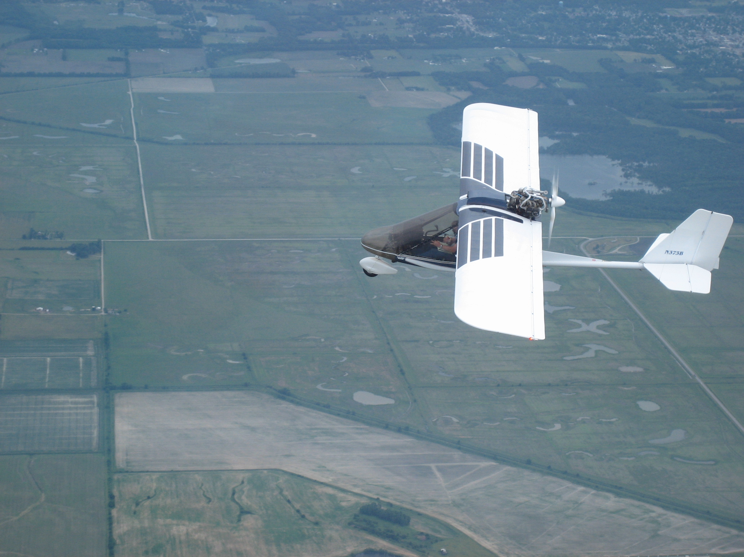
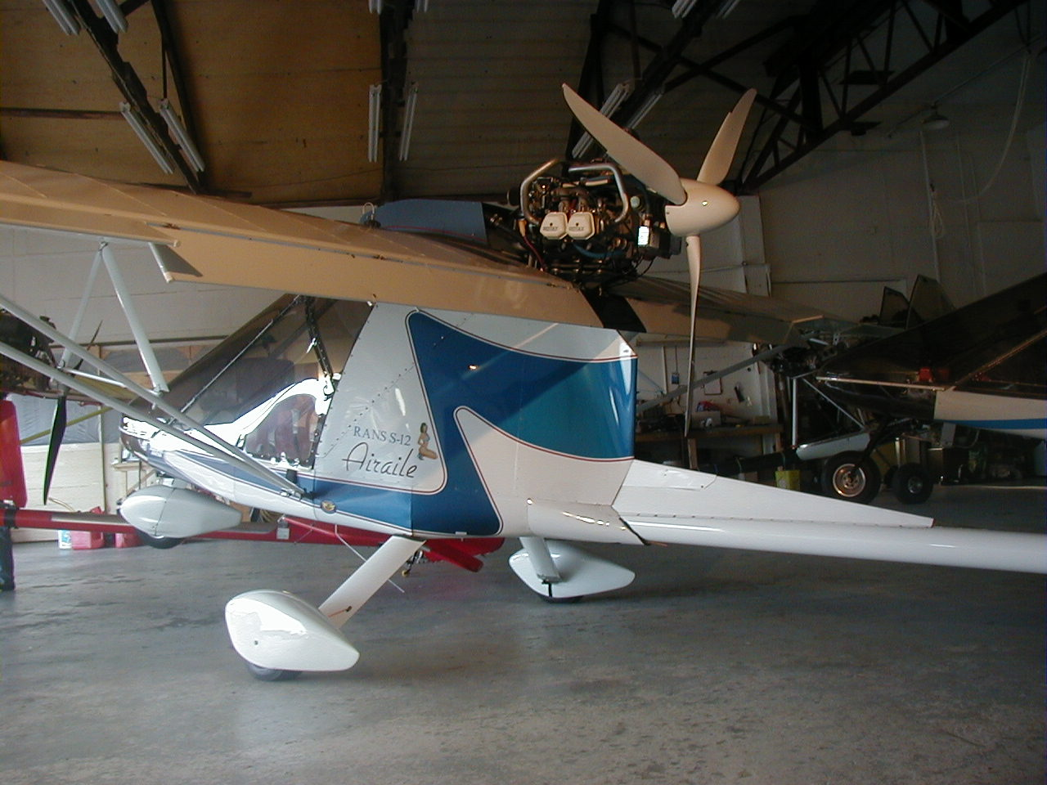

Enjoy the Sky!

UPDATED 6/1/19

